
CIRM Working Paper:
Manufacturer IDs for devices using a freeform maritime identity

CIRM Technical Office draft

Version: 3
Issued: April 2026

Overview

- CIRM has the responsibility for assigning manufacturer IDs to companies producing “devices using a freeform number identity” in accordance with Recommendation ITU-R M.585-9, i.e., AIS-SART (970), MOB (972) and EPIRB-AIS (974).

- Recent and pending revisions to Recommendations ITU-R M.1371 and M.585 introduce changes to the underlying numbering scheme. These changes will directly affect CIRM’s role and assignment procedures; however, the practical implications are not yet fully understood.

Background

- The 9-digit number assigned to devices using a freeform number identity is not an MMSI. Its original purpose was to allow such devices, once activated, to be received by AIS equipment and displayed to the user.

- Within this structure, the 2-digit manufacturer ID component was included to enable each manufacturer to assign unique identifiers to individual devices, thereby reducing the risk of duplicate numbers being transmitted simultaneously within the same area.

- Around 2012, concerns arose that the limited pool of manufacturer IDs (01–99) could be exhausted, partly due to the practice of assigning multiple IDs to individual manufacturers. In response, it was agreed that individual device numbers did not need to remain globally unique and could be re-used. Manufacturers were therefore expected to cycle through the 4-digit serial number range (0000–9999), removing the need for multiple manufacturer IDs per company.

- This approach was considered acceptable on the basis that the likelihood of multiple devices with identical numbers being active in the same area at the same time remained low

Exhaustion of manufacturer IDs

- From 2022 onwards, a sharp increase in requests for manufacturer IDs led to rapid depletion of the available pool. By 2024, all 99 IDs had been assigned.

- Throughout this period, CIRM kept both IMO and ITU informed of the situation through formal submissions, highlighting the need for a solution.

- Following exhaustion of the pool, and in line with guidance from ITU-R Working Party 5B (WP 5B), CIRM has continued to assign previously issued manufacturer IDs to new applicants.

Proposals considered and rejected

- CIRM has consistently maintained that a more robust and scalable numbering scheme is required in the long term. In the interim, several alternative approaches have been proposed and explored.

Allocating additional 97x numbers for AIS-SARTs, MOBs and EPIRBs

- Document 5B/588, submitted by CIRM to the November 2018 meeting of WP 5B, suggested that consideration should be given to the concept of allocating additional 97x numbers for AIS-SARTs, MOBs and EPIRBs, on the basis that this solution could provide a reasonable amount of additional capacity in the medium-term, while also noting that such a change would require a technical change to equipment already installed on vessels.

- In response, following the meeting WP 5B issued a liaison statement to CIRM and IMO (Annex 22 to Document 5B/646) concluding that the allocation of additional 3-digit prefixes would not provide a sufficient long-term solution for the identification of these devices as considered in document 5B/588 in particular AIS-SART, MOB and EPIRB-AIS.

Splitting the assignment of the current manufacturer IDs between the three types of devices

- Another proposal suggested allocating separate manufacturer ID pools for each device category (970, 972, 974). This approach was found to be impractical because:

- most manufacturers produce only one device type (predominantly MOB-AIS), meaning exhaustion would still occur within that category;

- it would introduce significant complexity and would not be compatible with existing assignments; and

- reliable information on how manufacturers use their IDs is difficult to obtain.

- This approach was therefore not pursued.

Solution - appending a suffix to AIS Message 14 burst transmissions

- The May 2024 meeting of WP 5B considered a proposal from CIRM to address the shortage of manufacturer by appending the alphanumeric “MPP” suffix to the safety related text of AIS Message 14 burst transmissions, thereby extending the transmitted identity from 9 digits to 12 characters.

- The intention of this approach was to significantly increase the available pool of manufacturer identifiers and device serial numbers without requiring changes to existing Message 1 transmissions.

- This proposal is being incorporated into the ongoing revision of Recommendation ITU-R M.585-9:

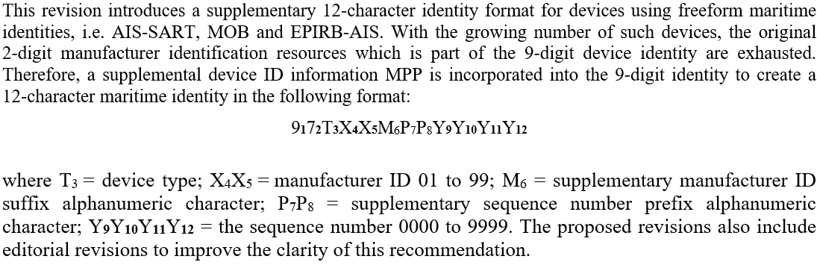

- Consequential updates were included in the revision of Recommendation ITU-R M.1371-6.

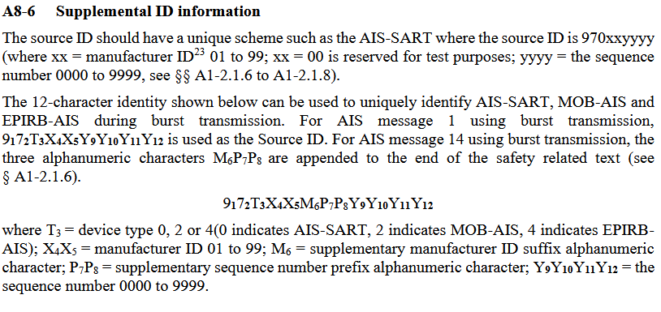

Technical characteristics of the new numbering scheme

- Under the updated numbering scheme:

- devices may transmit, through inclusion of the M₆P₇P₈ suffix, an extended 12-character identity via AIS Message 14;

- the existing 9-digit identity remains in use in AIS Message 1;

- the concept of “freeform number identity” is updated to “freeform maritime identity”;

- the extended 12-character identity is expected to be unique; and

- CIRM is tasked not only with assigning the 2-digit manufacturer ID (X₄X₅), but also the supplementary suffix (M₆).

Practical implications for CIRM

- The revised framework introduces a number of unresolved issues that directly affect CIRM’s responsibilities and procedures.

Unclear definition of manufacturer identity

- It is not clear whether the effective manufacturer identity is:

- the existing 2-digit manufacturer ID (X4X5), or
- the extended identity including the suffix (X₄X₅ + M₆).

- This distinction is fundamental to how assignments should be made and managed.

Mismatch between Message 1 and Message 14 identities

- The extended identity is transmitted only in Message 14, while Message 1 is expected to continue using the legacy 9-digit format. However, there is currently uncertainty as to which identifier manufacturers are expected to encode in Message 1 for devices implementing the new scheme. This creates a potential discrepancy between the two transmissions and raises questions about which identity should be considered authoritative in practice.

Lack of allocation framework for M₆ suffixes

- While CIRM is expected to assign M₆ suffixes, no guidance has been provided on how this should be done. There are no defined allocation principles nor guidance on reuse or limits.

Fairness and capacity considerations

- One suggestion is that all suffixes associated with a given X₄X₅ manufacturer ID should be reserved for the existing holder of that ID. However, this approach would:

- concentrate capacity within legacy allocations;
- disadvantage new entrants; and
- fail to significantly increase the number of available manufacturer identities.

Potential sharing of manufacturer IDs

- An alternative approach would allow multiple companies to operate under the same X₄X₅, differentiated by M₆ suffixes. However, this raises concerns regarding traceability and identity integrity, particularly given the continued use of the 9-digit identifier in Message 1.

Transition and backward compatibility

- The coexistence of legacy devices (using only the 9-digit identity) and new devices (using extended 12-character identities) introduces additional complexity. CIRM will need to consider how to manage assignments during this transition period without creating confusion or inconsistency.

Key questions

- Considering the above, the following questions require clarification:

  - What constitutes the effective manufacturer identity under the revised scheme? Is it (X₄X₅) or (X₄X₅ + M₆)?

  - How should M₆ suffixes be allocated, and according to what principles?

  - Can multiple manufacturers share a single X₄X₅ identifier, and if so, under what conditions?

  - How should the mismatch between Message 1 and Message 14 identities be handled operationally?

